Adventure Work Sales Analysis
Key Business Insights
The dashboard was designed to answer questions such as:
- How much revenue and profit are being generated?
- How is performance changing year over year?
- Which months generate the highest profit?
- Which weekdays perform best?
- How does weekday performance compare with weekends?
- Which products contribute the most to overall performance?
- Which customers generate the highest contribution?
- Which countries perform best?
- Which product colors generate the highest profit?
- Which customer age groups are the most profitable?
- How does product price category relate to performance?
- What percentage of total profit comes from the top-performing segments?
The interactive design allows these questions to be explored dynamically through filters and dashboard controls.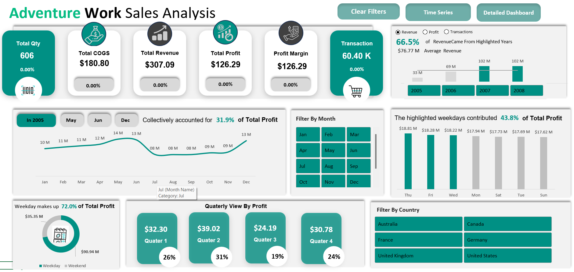
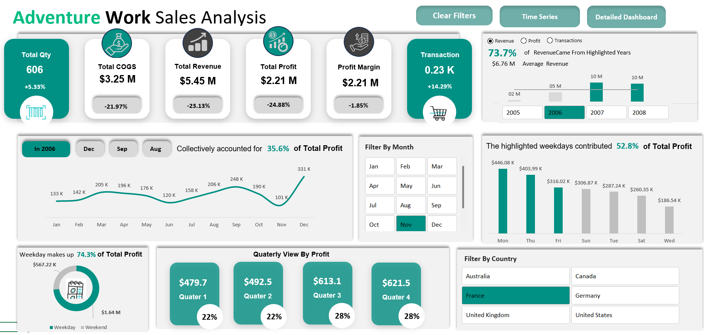
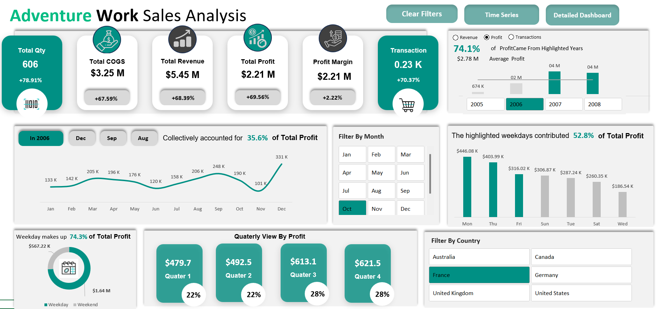
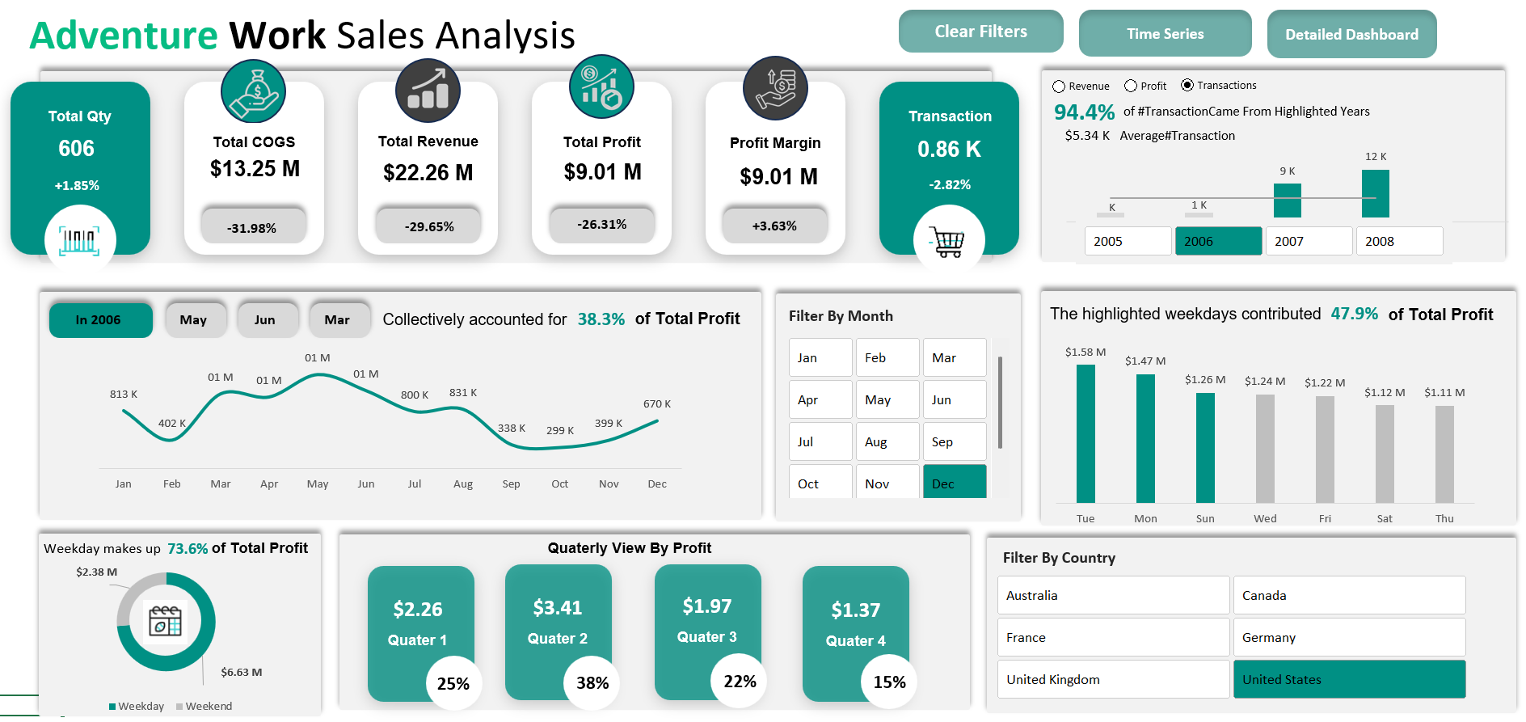
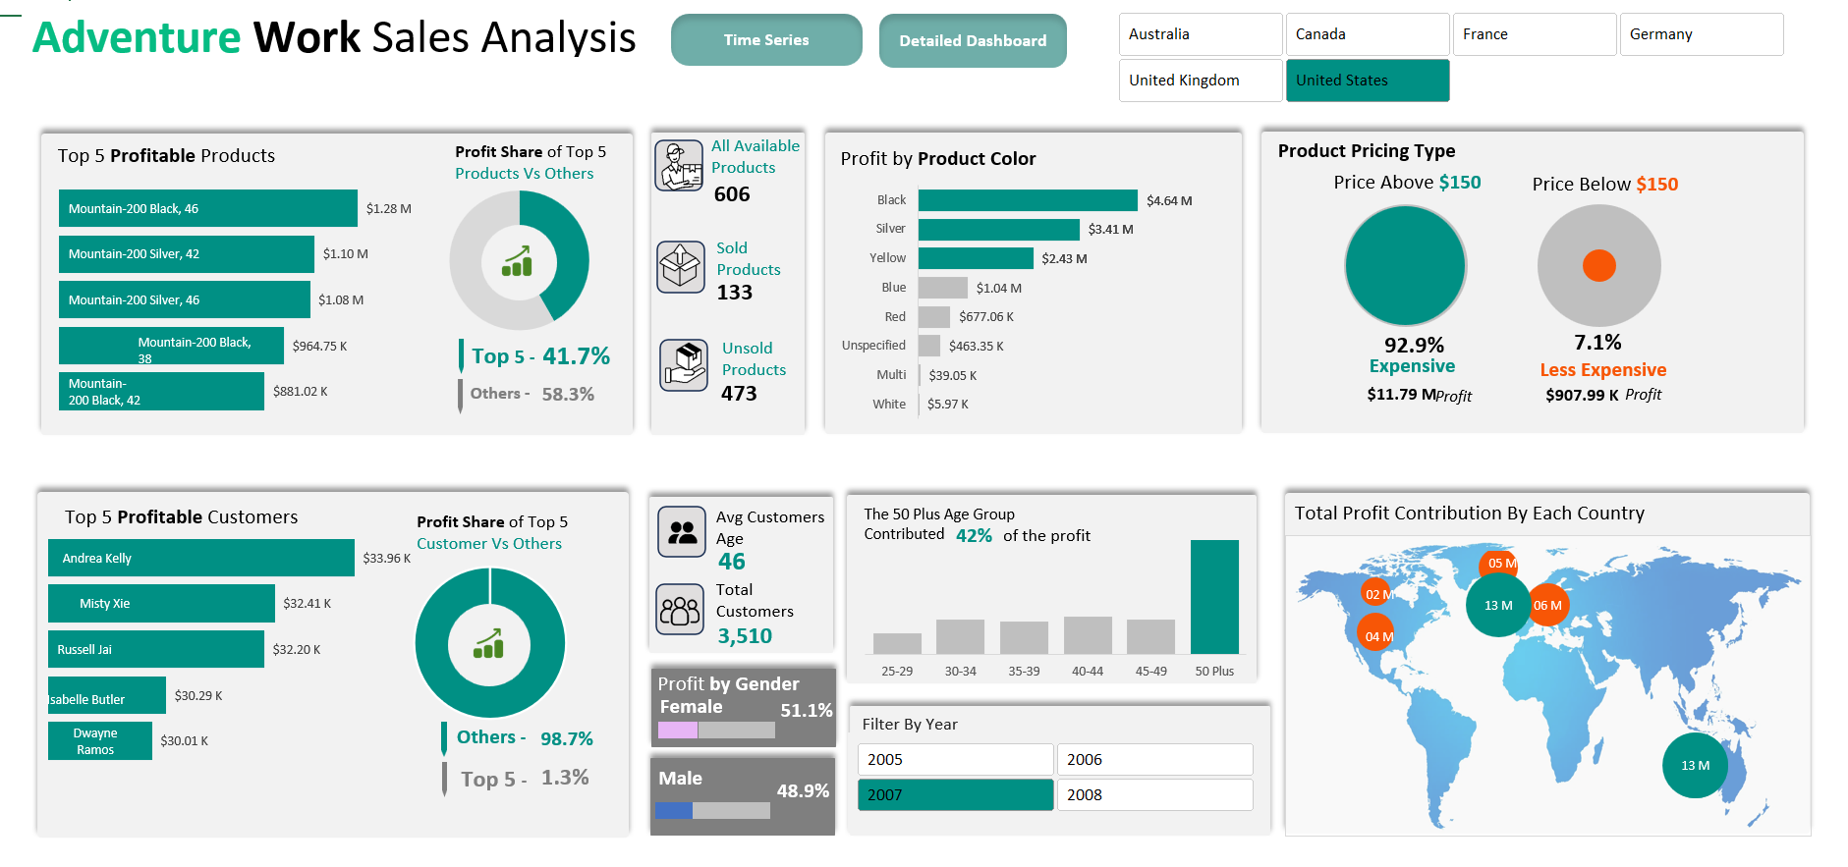
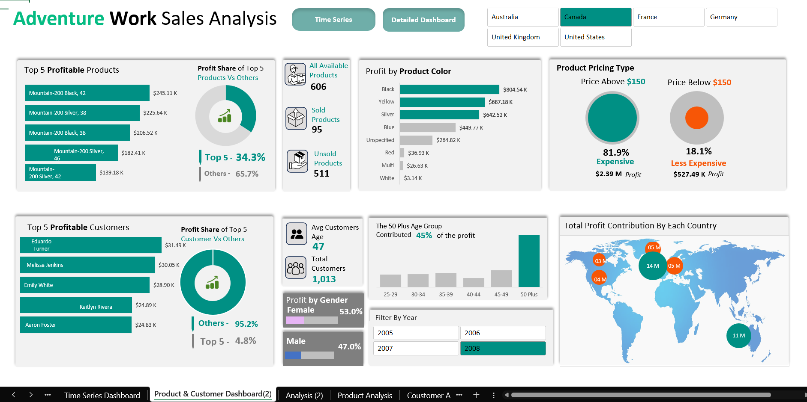
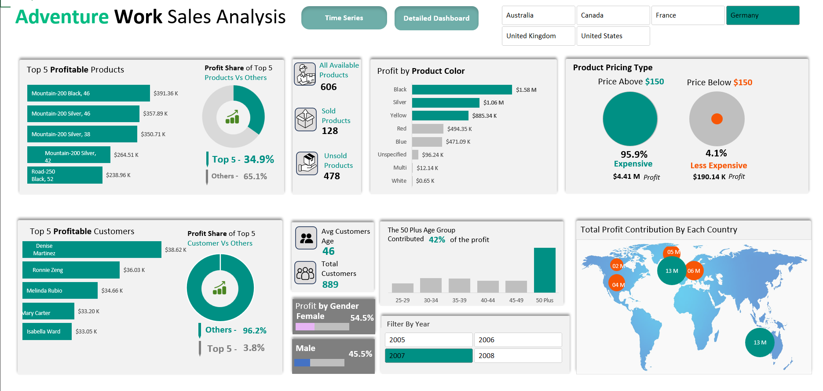

1. Data Cleaning & Transformation
Power Query was used to prepare the raw dataset before building the analytical model.
Data Preparation Included:
- Cleaning the Internet Sales fact table
- Cleaning Product data
- Cleaning Customer data
- Cleaning Geography data
- Cleaning Sales Territory data
- Handling missing and duplicate records
- Standardizing data types
- Creating calculated columns
- Creating additional analytical fields
Feature Engineering
Additional fields were created to support dashboard analysis, including:
- Customer Age
- Customer Age Group
- Product Price Category
- Week Number
- Weekday / Weekend Classification
- Week Type
- Month Number
- Year
- Quarter

2. Date & Time Intelligence
A dedicated Date Table was created to support time-based analysis.
The Date Table includes:
- Year
- Month
- Month Number
- Quarter
- Day
- Week Number
- Weekday
- Week Type
- Weekday / Weekend classification
Month and weekday sorting were also configured to ensure that charts display chronological order correctly.

3. Power Pivot & Data Modeling
The cleaned datasets were loaded into the Excel Data Model using Power Pivot.
A structured relational model was created by connecting fact and dimension tables.
Data Modeling Includes:
- Fact table
- Dimension tables
- Table relationships
- Date relationships
- Product relationships
- Customer relationships
- Geography relationships
- Sales Territory relationships
This model provides the foundation for dynamic PivotTables, PivotCharts, and DAX calculations.

4. DAX Measures & KPI Calculations
DAX was used to create dynamic measures for the dashboard.
Key Measures Include:
- Total Quantity
- Total Revenue
- Total COGS
- Total Profit
- Profit Margin
- Total Transactions
- Total Products
- Sold Products
- Unsold Products
- Total Customers
- Average Customer Age
Additional calculations were created for:
- Year-over-Year change
- Previous-year performance
- Contribution percentage
- Top-performing categories
- Average performance
- Dynamic business insights
Custom number formatting was also applied to display values in readable formats such as:
- K
- M
- B
- Currency
- Percentage

5. PivotTables & PivotCharts
PivotTables and PivotCharts were used extensively for exploratory analysis and dashboard visualizations.
They were used to analyze:
- Revenue
- Profit
- Transactions
- Products
- Customers
- Countries
- Months
- Quarters
- Weekdays
- Product colors
- Product price categories
- Customer age groups
- Gender
- Weekday vs Weekend performance

6. Time-Series & Performance Analysis
The dashboard includes detailed time-based analysis.
Monthly Analysis
- Monthly Revenue
- Monthly Profit
- Monthly Transactions
- Monthly trends
- Average performance
- Top-performing months
Quarterly Analysis
- Q1 performance
- Q2 performance
- Q3 performance
- Q4 performance
- Quarterly contribution %
Year-over-Year Analysis
The dashboard compares selected-year performance with the previous year.
The analysis includes:
- Revenue YoY %
- Profit YoY %
- Profit Margin YoY %
- COGS YoY %
- Transactions YoY %
The dashboard also dynamically handles situations where previous-year data is unavailable.

7. Top-Performing Analysis
Dynamic calculations were used to identify the highest-performing areas.
Top 3 Months
- Identify the top 3 profit-generating months
- Calculate their contribution to total profit
- Dynamically display the corresponding months
- Generate insight text
Top Weekdays
- Identify the top-performing weekdays
- Calculate contribution to total profit
- Highlight top-performing days
- Compare weekday performance
Top Products
- Identify the Top 5 products
- Rank products based on performance
- Calculate Top 5 contribution
- Display results dynamically
Top Customers
- Identify the Top 5 customers
- Rank customers by performance
- Calculate Top 5 customer contribution
- Analyze customer performance by country
Top Countries
- Identify the Top 2 countries
- Calculate their combined contribution
- Dynamically identify the countries
- Highlight them in the geographic analysis

8. Product Analysis
The Product Analysis section provides detailed insights into product performance.
Analysis Includes:
- Top 5 Products
- Product availability
- Sold Products
- Unsold Products
- Profit by Product Color
- Product price segmentation
- Product price visualization
Product Price Segmentation
Products were categorized into price groups using Power Query.
Example categories:
- Less Expensive
- Expensive
This classification was then used for further dashboard analysis.
A custom visualization was also created to represent the different product price categories.

9. Customer Analysis
The Customer Analysis section focuses on customer behavior and demographics.
Analysis Includes:
- Top 5 Customers
- Total Customers
- Average Customer Age
- Customer Age Groups
- Profit by Gender
- Profit by Age Group
- Customer contribution
Customer Age Analysis
Customer age was calculated dynamically using Power Query based on the customer's date of birth.
Age groups were then created, including categories such as:
- 0–24
- 25–29
- 30–34
- 35–39
- 40–44
- 45–49
- 50+
This allows customer profitability to be analyzed across different age groups.

10. Geographic Analysis
Geographic analysis was created to understand performance across countries.
The dashboard includes:
- Country-level filtering
- Profit by country
- Top-performing countries
- Country contribution %
- Geographic comparison
A custom bubble-map style visualization was created using country coordinates and a background map/vector image.
Bubble size was used to represent the selected performance metric.

11. Dynamic Visualizations
The dashboard was designed to provide an interactive visual storytelling experience.
Visualizations Include:
- KPI cards
- Line charts
- Bar charts
- Donut/Pie charts
- Custom bubble visualizations
- Geographic bubble map
- Top-N visualizations
- Dynamic charts
- Contribution visualizations
The dashboard also uses dynamic captions and insight statements to explain the displayed results.

12. Interactive Dashboard Features
Several interactive features were implemented to make the dashboard dynamic.
Slicers
Interactive slicers were created for:
- Year
- Month
- Country
The slicers were connected to relevant dashboard analysis sections.
Slicer Synchronization
Slicers were synchronized across different dashboard sections so that selections can affect multiple visualizations simultaneously.
Dynamic Metric Selection
Form Control Option Buttons were used to allow users to switch between:
- Revenue
- Profit
- Transactions
The selected metric dynamically changes the corresponding visualization.

13. VBA / Macro Automation
A Clear Filters button was created using VBA/macros.
The button allows users to clear selected dashboard filters without manually resetting each slicer.
This improves dashboard usability and provides a more application-like experience.

14. Dashboard Navigation
Navigation buttons were implemented to allow users to move between different dashboard sections.
Example sections include:
- Time Analysis
- Detailed Dashboard
- Product Analysis
- Customer Analysis
- Geographic Analysis
Internal workbook navigation and interactive buttons were used to create a smooth dashboard experience.

